Week | News Story | Focus Question | UN Article | UN Link | British Value Link | Protected Characteristics
2nd January | A flatpack wind turbine, invented by Douglas Macartney from Scotland, is to help provide power to communities in Kenya, Africa. | Should all the energy we use be renewable? | 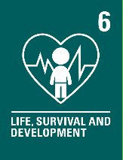 | Having electricity and heating in our homes and schools can help ensure we survive and develop in the best possible way. Governments must make sure all children survive and develop in the best way possible. | Democracy - Energy is required to power many of the useful and convenient items we use daily. This energy can be produced in many different ways. We can use our voices to share our thoughts on this and impact the future. | Age - Young people can be overlooked for their ideas because they may not be as experienced as adults but when given the opportunity, they can often make a valuable contribution.
9th January | 18-year-old Andrea Spendolini-Sirieix has been named as a BBC Young Sports Personality of the Year finalist. | Can you learn how to manage under pressure? | 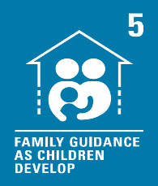 | Governments should let our families and communities guide us. They can help us find ways to respond to life’s pressures and learn to use our rights in the best way. As we grow, we will need less guidance. | Mutual Respect and Tolerance - We are all different so the way we respond to the demands or pressures we may face will be different too. We understand and respect that not everyone is the same and everyone needs to be treated as an individual. | Sex - ‘I think this year especially has shown that women are strong and nothing can stop you doing what you want to do. Your age or gender don’t stop you.’ – diver, Andrea Spendolini-Sirieix
16th January | Many of us are increasingly reusing, repairing, and upcycling items, instead of throwing them away and replacing with new ones, according to experts. | Do we throw things away too easily? | 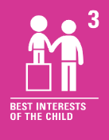 | When adults make decisions, such as what items we should learn to repair and when, they should think about how it will affect us. They should make sure we are safe and protected. | Individual Liberty - It is important to remember all our actions have consequences. If we choose to repair items, we can save money, help the environment and learn new skills. | Religion or Belief - Some people throw away more than others because of their beliefs. Our beliefs affect our life choices and the way we live our life.
23rd January | A drink called ‘Prime Hydration’ has arrived in the UK and as quickly as it arrived, it sold out. | How much control do influencers have over our choices? | 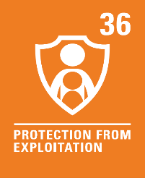 | We all have the right to be protected from exploitation (being taken advantage of). Learning about social media and keeping safe online can help do this. | Mutual Respect and Tolerance - We all have the power to influence so should consider how our behaviour, actions and words can affect others. | Religion or Belief - Our beliefs consist of the things we believe to be true about ourselves, the world and others. They are firmly embedded and affect the way we think and behave. There are many things which may influence our beliefs.
30th January | Brazil's new president has said he aims to reduce deforestation and help protect the Amazon rainforest. | Does the natural world have rights? |  | We have the right to share what we have learned about the deforestation of the Amazon rainforest. We can also share what we think and feel about it unless it harms other people. | Rule of Law - Rules and laws can be put in place to help protect the natural world. We are all responsible for these rules and laws. | Race - Luiz Inácio da Silva is Brazilian. This is his nationality. People around the world can unite to reduce the deforestation of the Amazon rainforest. Our nationality must never stop us doing something.
6th February | The Welsh Football Association has announced that the national men and women's football teams will be paid equally moving forward. | Should men and women’s sports teams be paid the same? | 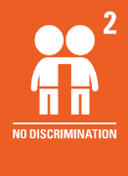 | All children have rights and should not be treated unfairly for any reason. This includes whether we are a girl or a boy. | Democracy - If we do not agree with something or do not think it is fair, we can use our voices to make changes. Wales’ national men and women's football teams will now receive equal pay. | Sex - Both men and women should be treated fairly. This includes being paid fairly for the job they do.
13th February | Humans can understand other apes’ common methods of sign language, scientists have just discovered. | What is the most important form of communication? | 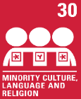 | There are many languages spoken across the world that people can use to communicate with one another. We all have the right to use our own language, even if this is not shared by most people in the country we live in. | Mutual Respect and Tolerance - We are all different, so communicate in different ways. Developing our communication skills can help us become more understanding of the world we live in and may even help someone else feel welcome and cared for. | Disability - Some people may have a disability, such as deafness, which means they communicate with others in a different way. This should never cause someone to be treated unfairly.

