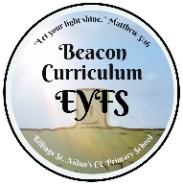
EYFS LONG TERM PLAN - SCIENCE
Autumn 1 | Autumn 2 | Spring 1 | Spring 2 | Summer 1 | Summer 2
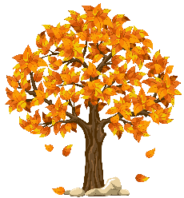  Autumn walk. What happens to the trees in Autumn? | 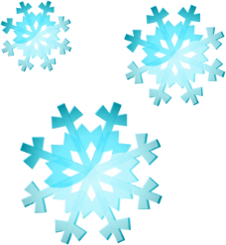  Ice-how we can freeze liquids.  Weather  Winter | 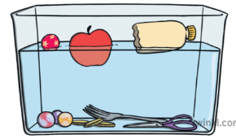  Floating and sinking. | 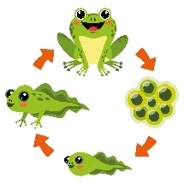  Life cycle of insects  Life cycle of a flower  Minibeasts  Spring-What happens to the trees in Spring? | 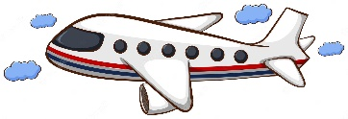  How vehicles move. Different types of vehicles including air transport. | 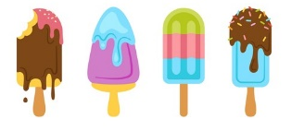  Seasons.  Weather  Climate  Objects that melt.

