NURSERY LONG TERM PLAN – MATHEMATICS 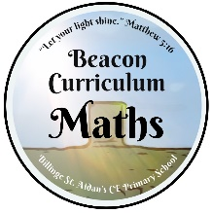
Autumn 1 | Autumn 2 | Spring 1 | Spring 2 | Summer 1 | Summer 2
Fast recognition of up to 3 objects, without having to count them individually (‘subitising’).  • Recite numbers past 5.  • Say one number for each item in order: 1,2,3,4,5.  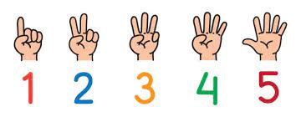 | Know that the last number reached when counting a small set of objects tells you how many there are in total (‘cardinal principle’).  • Show ‘finger numbers’ up to 5.  • Link numerals and amounts: for example, showing the right number of objects to match the numeral, up to 5. | Experiment with their own symbols and marks as well as numerals.  • Solve real world mathematical problems with numbers up to 5.  • Compare quantities using language: ‘more than’, ‘fewer than’.  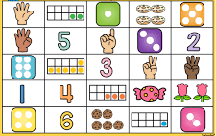 | Talk about and explore 2D and 3D shapes (for example, circles, rectangles, triangles and cuboids) using informal and mathematical language: ‘sides’, ‘corners’; ‘straight’, ‘flat’, ‘round’.  • Understand position through words alone – for example, “The bag is under the table,” – with no pointing.  • Describe a familiar route.  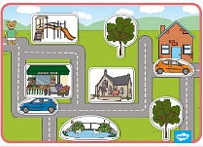 | Discuss routes and locations, using words like ‘in front of’ and ‘behind’.  • Make comparisons between objects relating to size, length, weight and capacity.  • Select shapes appropriately: flat surfaces for building, a triangular prism for a roof etc.  • Combine shapes to make new ones – an arch, a bigger triangle etc. | Talk about and identifies the patterns around them. For example: stripes on clothes, designs on rugs and wallpaper. Use informal language like ‘pointy’, ‘spotty’, ‘blobs’ etc.  • Extend and create ABAB patterns – stick, leaf, stick, leaf.  • Notice and correct an error in a repeating pattern.  