Week | News Story | Focus Question | UN Article | British Value Link
24th  October | After being shut for nearly two years, the world’s most  southerly mail room on the remote Goudier Island in the  Antarctic Peninsula, will reopen under a team of British women. | How can we keep ourselves warm outside in winter? | 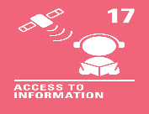 | Mutual Respect and Tolerance - In winter, it’s important to stay warm. We all need to wear warm clothes. Some clothes we may like more than others. We should always show respect for what other people choose to wear.
31st  October | A robot named Ai-Da has become the first robot to speak in the House of Lords in Westminster, London. | If you were to make your own robot, what would it be able to do? | 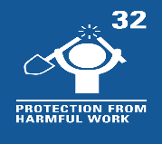 | Individual Liberty - People choose to build robots that are able to do different things. When designing and making a robot, people should think about how the robot will help us and make sure everyone stays safe.
7th  November | Animal rescue groups in countries around the world are seeing a jump in the number of animals being brought to their shelters, as household finances are squeezed. | How do people take good care of their dogs? |  | Democracy - We all have a voice. We can use our voice to share what we think about the things that matter to us. For some, this might be caring for pets in need.
14th November | Pupils in schools should not be unfairly singled out for having afro hair, the Equality and Human Rights Commission (EHRC) has said in new guidelines for schools. | What are some of the different types and styles of hair? | 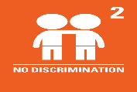 | Rule of Law - There may be rules we follow in school about how we wear our hair. Rules are often in place to protect us and keep us safe but we must ensure they are fair to everyone.
21st November | The men’s FIFA World Cup 2022 has started in Qatar and will run until 18th December. | What are some of the rules of football? | 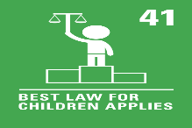 | Mutual Respect and Tolerance - World sports events provide  an opportunity to learn about other countries and their cultures. Life is not the same for everyone and we can respect our differences.
28th  November | Nurses in the Royal College of Nursing (RCN) union have voted for the union’s first UK-wide strike in its 106-year history. | What would be the best job for you? | 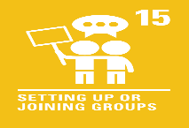 | Democracy - We all have a voice and the right to use it. Nurses in the Royal College of Nursing union have voted to strike, which is one way people can share their voice.
5th  December | This year, the BBC (British Broadcasting Corporation)  marks 100 years of broadcasting. | Does everyone enjoy watching television? |  | Individual Liberty - With such a huge variety of television programmes available on our screens, we can choose what to watch. We can take some responsibility to ensure we have a healthy amount of screen time.
12th  December | Nasa officials have recently announced that humans could live on the Moon during this decade. | Which places would you most like to visit? |  | Mutual Respect and Tolerance - We are all different so our thoughts, feelings and opinions about visiting the Moon will be different too. We can show respect for and understanding  of our differences.

