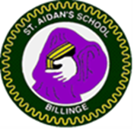
Billinge St Aidan’s CE Primary School
Let your light shine… Matthew 5:16
AIDAN’S ANNOUNCER

Upcoming dates  Term Dates  School closes on Friday 12th February 2021  School reopens for HT4 on Monday 22nd February 2021  Remote learning is in operation at present and school open to key workers and vulnerable pupils. | Head Teacher message  Well what a start to the week ! Snow , ice – LOCKDOWN !  I am grateful that we got to touch base with our school family on Monday even though it was a stressful day in relation to the mounting pressure for schools to close once more.  We are all fully aware of the pressures that this closure brings but I need to stress as a matter of importance that we are here for you and we don’t want any family to struggle in anyway.  There are lots of ways in which we can help so I urge you to contact your class teacher, the school office or myself and ask the question. We will continue to go above and beyond for our families. We are a Church and Christian school so our commitment goes further than just providing education.  I want to say a huge thankyou to the whole staff this week .The St Aidan’s ship has readjusted its sails whilst we head into this period . Every single member of staff has gone above and beyond.  There has been a lot of information about home learning that has been sent out via school spider and we are checking which parents have received this and are engaging with the teachers. This is a requirement and so if you have problems with this then will assist you- again please ask.  I truly believe that we are part of something specual here and I would like to share this video with you which encmpases out school. Applications for Reception places 2021 close on 15th January so please share this video to welcome more incredible families into our school family. We also have 6 current places available also so if you know of anyone who has recently moved into the area please share it with them also  https://www.youtube.com/watch?v=YFdA8ppWwv8 so proud of the children for making this video in a socially distanced way.  Stay Safe everyone and please keep in touch especially if your family becomes directly affected for the coronanvirus  Mrs Fisher Acting Headteacher
Remote Learning – Messages from teachers
The teachers have sent out many emails and communications for your child to fulfil our remote learning offer. Microsoft is our chosen platform and Year 4 and 6 have trialled this. Other Year groups will follow. I would like to say a huge thankyou to all the staff who have switched with hours notice to remote learning and are also in school with Keyworker and vulnerable groups.
We have quite a lot of parents who have requested packs . Please note that these are not the same as the teaching activities that are going on the website . They are revision of skills but no new teaching. The best activities are on the website. If you have problems with devices then please contact school.
We need to take some time this weekend and take in everything that has happened this week.
Please contact school if you have any concerns during the school closure especially if you have issues around accessing the school website with technology and other websites.
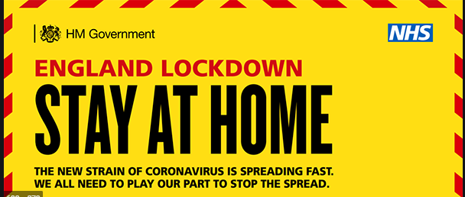

https://www.gov.uk/guidance/national-lockdown-stay-at-home
St Aidan’s is now a ‘voucher school’ for St Helens Foodbank . Please do
not go without food during this Lockdown. If you need help please phone the school office and ask for Mrs Fisher using the reference’ Lockdown chat,’Full discretion will be applied .

We have the vouchers in school.

Virtual Days Out – Stay home and virtually go out !

https://www.youtube.com/watch?v=mBj_tzgpFZMwill Cinderella and the Beanstalk – Have a family afternoon at the panto !
https://www.chesterzoo.org/virtual-zoo-2/
https://www.nationalfootballmuseum.com/communities/stayathome/
https://www.pottertrail.com/videotours
https://www.nationalgallery.org.uk/visiting/virtual-tours
https://www.hrp.org.uk/discover-the-palaces/#gs.q2qng6 Historic Royal Palaces

