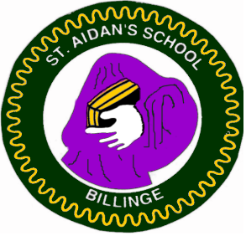
Safeguarding/Child Protection
If you have any concerns:
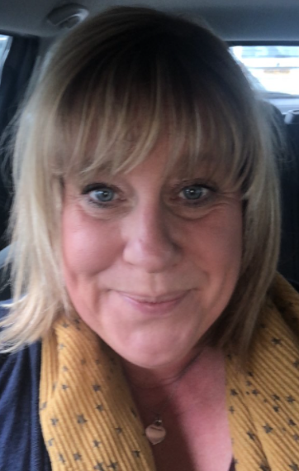

Mrs Fisher is The Designated Safeguarding Lead
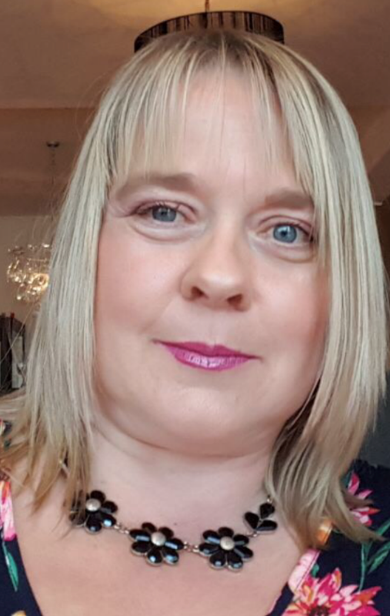

Mrs Benetatos is The Deputy Designated Safeguarding Lead What to do if you are not sure whether to make a contact or referral
- Talk to the designated professional within your agency or your line manager about your concerns
- Telephone the MASH Team through the Contact Cares Team (01744) 676767 and ask for the Duty Social Worker- Out of hours 0345 050 0148

