Week | News Story | Focus question | UN Article | UN Link | British Value Link | Protected Characteristics
20th February | Long-term bike hire schemes are on the rise. Several companies have launched services, where users can pay a monthly fee to use a high-quality bike or e-bike. | Should everyone have access to a mode of transport? | 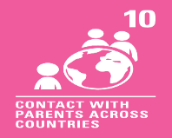 | If a child lives in a different country than their parents, governments must let the child and parents travel, so they can stay in contact and be together. | Individual Liberty - There are many factors that may influence how we choose to travel. It is important to consider the consequences of our choices and the impact they may have on ourselves, others and the environment. | Religion or Belief – Our beliefs affect our life choices and how we live our lives. For some people, their beliefs may affect the mode of transport they choose to use.
27th February | A safe, digital pound that can be used in shops or online is likely to be needed for the future, the government has said. | Will the world become cashless in the future? | 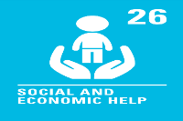 | Governments should provide money or other support to help children from poor families. | Individual Liberty - People can choose how they spend their money. There may be benefits and consequences of spending money in each of its forms, which may vary for each individual. | Age - There may be times when someone’s age affects how they spend their money. Not all children have bank cards or mobile phones and not all adults want to use them either. Everyone should be able to choose how they spend their money.
6th  March | It has been suggested that the number of hazel dormice in the UK has dropped from around 3.5 million to only 750,000 in almost 30 years. | Could you do more to protect your local area? | 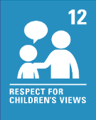 | We have the right to give our opinions freely about any issues that affect us such as issues in our local area. Adults should listen to us and take us seriously. | Democracy - We all have a voice and our opinions should be heard. If we want to help care for and protect natural habitats, we can use our voice and take action. | Religion or Belief - For some people, caring for and protecting natural environments form part of their beliefs. It will affect their life choices or how they live their life.
13th  March | Book publisher, Puffin, has announced that stories by the famous children's author Roald Dahl are going to be changed, making them more suitable for modern times. | Should Roald Dahl’s books be changed for modern times? | 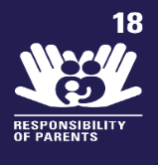 | Parents or guardians are the main people responsible for bringing up a child. They should always consider what is best for us. This may involve deciding which books are suitable for us to read. | Rule of Law - As we move into the future, things develop, change and modernise. Rules and laws will sometimes need to be updated because of this. | Age - Roald Dahl was born in 1916. He based many of his stories and characters on his real life experiences. People of different ages are likely to have different life experiences but we should never be treated unfairly because of our age or the age group we are in.
20th  March | Sight loss charity, The Guide Dogs for the Blind Association, has launched an appeal for volunteers to help raise and foster guide dogs. | How important are guide dogs for those in need? | 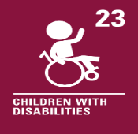 | Every child with a disability should enjoy the best possible life in society. Guide dogs can help people who are blind or partially sighted become more independent and to participate actively in the community. | Mutual Respect and Tolerance - My behaviour, actions and words can affect others. Volunteering is an action that can affect others in a positive way and help make a difference to their lives. | Disability - A guide dog can help someone who is blind or partially sighted to live their life to the full.
27th  March | Schools in parts of Turkey and Syria have been reopening in the weeks since devastating earthquakes hit, many in the form of makeshift tents. | How do communities support each other in difficult times? | 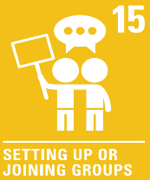 | We can join or set up groups or organisations and form our own communities. We can meet with others as long as this does not harm other people. | Mutual Respect and Tolerance - Community groups can be formed by people with similar interests or characteristics. Not everyone shares the same interests or characteristics as each other but we can respect that. | All - Some communities can be formed based on people’s characteristics. These nine characteristics are protected so nobody should be treated unfairly because of them.

