RECEPTION LONG TERM PLAN – MATHEMATICS 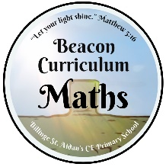
Autumn 1 | Autumn 2 | Spring 1 | Spring 2 | Summer 1 | Summer 2
Work with numbers 1-5 | Work with numbers 1-10 | Number recognition 1-15 | Number recognition 1-20 | Compare length, weight and  capacity.  Number bonds up to 5 and some number bonds to 10,  Subtraction facts  Double facts  Explore and represent patterns within numbers up to 10, including evens and odds, double facts and how quantities can be  distributed equally.  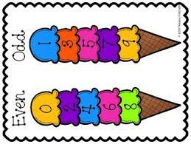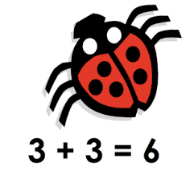  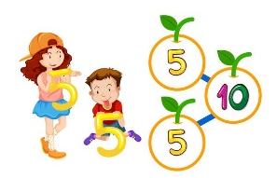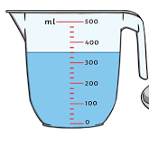
Count objects, actions, and sounds.
Subitise.
Link the number symbol (numeral) with its cardinal number value.
Count beyond ten.
Compare numbers.
Verbally count beyond 20, recognising the pattern of the counting system.
Understand the ‘one more than/one less than’ relationship between consecutive numbers.
Explore the composition of numbers to 10.
Recall number bonds for numbers 0–5 and some to 10.
Select, rotate, and manipulate shapes to develop spatial reasoning skills.
Compose and decompose shapes so that children recognise a shape can have other shapes within it, just as numbers can.
Continue, copy and create repeating patterns.

