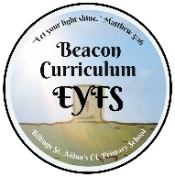
EYFS LONG TERM PLAN - HISTORY
Autumn 1 | Autumn 2 | Spring 1 | Spring 2 | Summer 1 | Summer 2
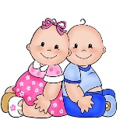  Talk about our family. Name our family. Bring photos into school from when we were babies. Talk about what we can do now and what we want to be able to do in the future.  What did your Mum, Dad etc look like as children?  Talk about the royal family and the King, from past, present and future. | 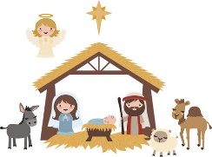  Talk about the past in stories, and how some stories have been read for years….Cinderella, Snow white etc.  The Nativity Story | 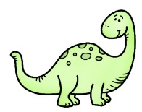  Look at animals that have now become extinct.  All about Dinosaurs | 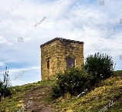  Look at what our community was like in the past, and how it has changed. Talk about members of our family who came to our school when they were little. | 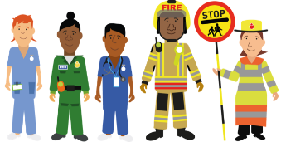  Talk about the roles of our family members in society. Ask family members to come and talk to the class… police, nurse, post person.  Look at vehicles, past and present. | Our Reception year. What can we do now that we couldn’t do in September? How much have we learned? How much have we changed?

