RECEPTION LONG TERM PLAN – LITERACY (WRITING) 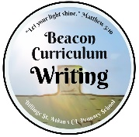
Autumn 1 | Autumn 2 | Spring 1 | Spring 2 | Summer 1 | Summer 2
Form lower-case and capital letters correctly.  Spell words by identifying the sounds and then writing the sound with letter/s.  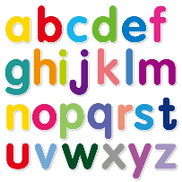 | Form lower-case and capital letters correctly.  Spell words by identifying the sounds and then writing the sound with letter/s.  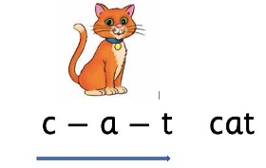 | Write recognisable letters, most of which are correctly formed.  Re-read what they have written to check that it makes sense.  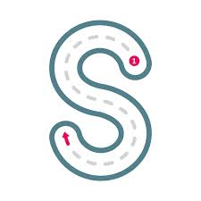 | Write short sentences with words with known letter-sound correspondences using a capital letter and full stop.  Re-read what they have written to check that it makes sense. | Spell words by identifying sounds in them and representing the sounds with a letter or letters.  Write simple phrases and sentences that can be  read by others, using a capital letter, finger space and full stop. | Spell words by identifying sounds in them and representing the sounds with a letter or letters.  Write simple phrases and sentences that can be  read by others, using a capital letter, finger space and full stop.

