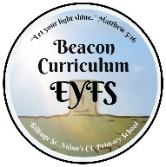
EYFS LONG TERM PLAN - GEOGRAPHY
Autumn 1 | Autumn 2 | Spring 1 | Spring 2 | Summer 1 | Summer 2
Get to know our school. Where the hall is for assembly, the office, the main entrance, the track etc. | 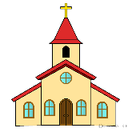  Compare characters from stories.  Walk around our community.  Look at features of our own community, library, church, memorial etc. | Look at the beliefs and celebrations of people in other countries.  Chinese New Year. | 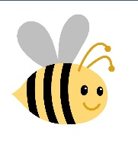  Look at different types of houses.  Planting  Mini beasts  Animals  Weather | 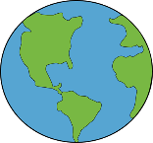  Look at lives in other countries. Outside world.  Summer walk.  Looking after our planet.  Road safety. | 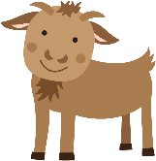  Look at different environments such as City, rural, farm.

