Week | News Story | Focus question | UN Article | UN Link | British Value Link
20th February | Long-term bike hire schemes are on the rise. Several companies have launched services, where users can pay a monthly fee to use a high-quality bike or e-bike. | How would you choose to travel? | 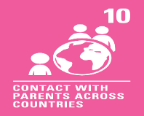 | If a child lives in a different country than their parents, governments must let the child and parents travel, so they can stay in contact and  be together. | Individual Liberty - We can travel in many different ways and there are lots of different types of transport to choose from. Walking or biking can help the environment.
27th February | A safe, digital pound that can be used in shops or online is likely to be needed for the future, the government has said. | Do you like to spend or save money? | 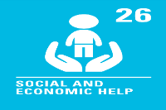 | Governments should provide money or other support to help children from poor families. | Individual Liberty - People can choose how they spend their money.
6th  March | It has been suggested that the number of hazel dormice in the UK has dropped from around 3.5 million to only 750,000 in almost 30 years. | How can we help protect wild animals where we live? | 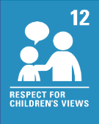 | We have the right to give our opinions freely about any issues that affect us such as issues in our local area. Adults should listen to us and take us seriously. | Democracy - We all have a voice and our opinions should be heard. If we want to help care for and protect natural habitats, we can use our voice and take action.
13th  March | Book publisher, Puffin, has announced that stories by the famous children's author Roald Dahl are going to be changed, making them more suitable for modern times. | Can you think of words to describe a character? | 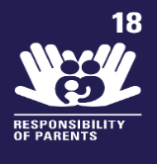 | Parents or guardians are the main people responsible for bringing up a child. They should always consider what is best for us. This may involve deciding which books are suitable for us to read. | Rule of Law - As we move into the future, things develop, change and modernise. Rules and laws will sometimes need to be updated because of this.
20th  March | Sight loss charity, The Guide Dogs for the Blind Association, has launched an appeal for volunteers to help raise and foster guide dogs. | How can guide dogs help people who are blind or partially sighted? | 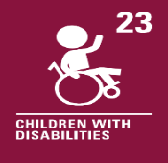 | Every child with a disability should enjoy the best possible life in society. Guide dogs can help people who are blind or partially sighted become more independent and to participate actively in the community. | Mutual Respect and Tolerance - Everyone is different. Some people need help to do some things. Volunteering can be one way we can help make a difference to other people’s lives.
27th  March | Schools in parts of Turkey and Syria have been reopening in the weeks since devastating earthquakes hit, many in the form of makeshift tents. | When might someone put up a tent? | 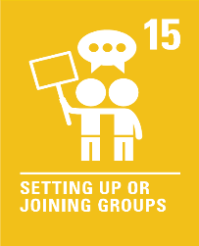 | We can join or set up groups or organisations and form our own communities. We can meet with others as long as this does not harm other people. | Mutual Respect and Tolerance - People live all over the world and everyone has different lives and experiences. We should always show respect to other people.

