‘Let your light shine’ – Matthew 5 v16

Policy: | Mathematics Policy
Date Agreed: | December 2023
Agreed by:
Review by: | July 2024

INTENT
-To enable pupils to be proficient, competent and confident with numbers, shapes and measures, and to have the ability to solve routine and non-routine mathematical problems.
- To foster positive attitudes towards mathematics by developing pupils’ confidence in using mathematical equipment and vocabulary, and through developing their mental strategies.
- To develop the ability to communicate mathematics.
- To develop an understanding of mathematics through a process of enquiry and experiment.
These will, in turn, work towards the aims of the National Curriculum (2014) for all pupils to:
- To become fluent in the fundamentals of mathematics, including through varied and frequent practice with increasingly complex problems over time, so that pupils develop conceptual understanding and the ability to recall and apply knowledge rapidly and accurately.
- To reason mathematically by following a line of enquiry, conjecturing relationships and generalisations, and developing an argument, justification or proof using mathematical language.
- To solve problems by applying their mathematics to a variety of routine and non-routine problems with increasing sophistication, including breaking down problems into a series of simpler steps and persevering in seeking solutions.

IMPLEMENTATION
We use the White Rose Maths Hub long-term, medium-term and small steps planning and the associated resources. This ensures progression both in objectives and calculation methods through whole school standardised methods: concrete, pictorial and abstract. Teachers also have access to the Master The Curriculum and Twinkl White Rose Maths resources that are designed to run alongside the scheme. Teachers are also encouraged to use NRich, HeadStart Primary and NCETM resources and publications to assist in planning for fluency, reasoning and problem solving. The teaching of mathematics will be in line with the whole school teaching and learning policy. It will also be wholly compatible with the school aims and mission. Depth of knowledge is the basis of our teaching and challenges/activities are encouraged to follow in these three interlinked areas:
- FLUENCY
- REASONING
- PROBLEM SOLVING

Problem Solving is taught indiscrete standalone lessons, with an assurance that all 5 strands of problem solving are taught over the year.

Fluency and Reasoning questions are covered in each lesson.
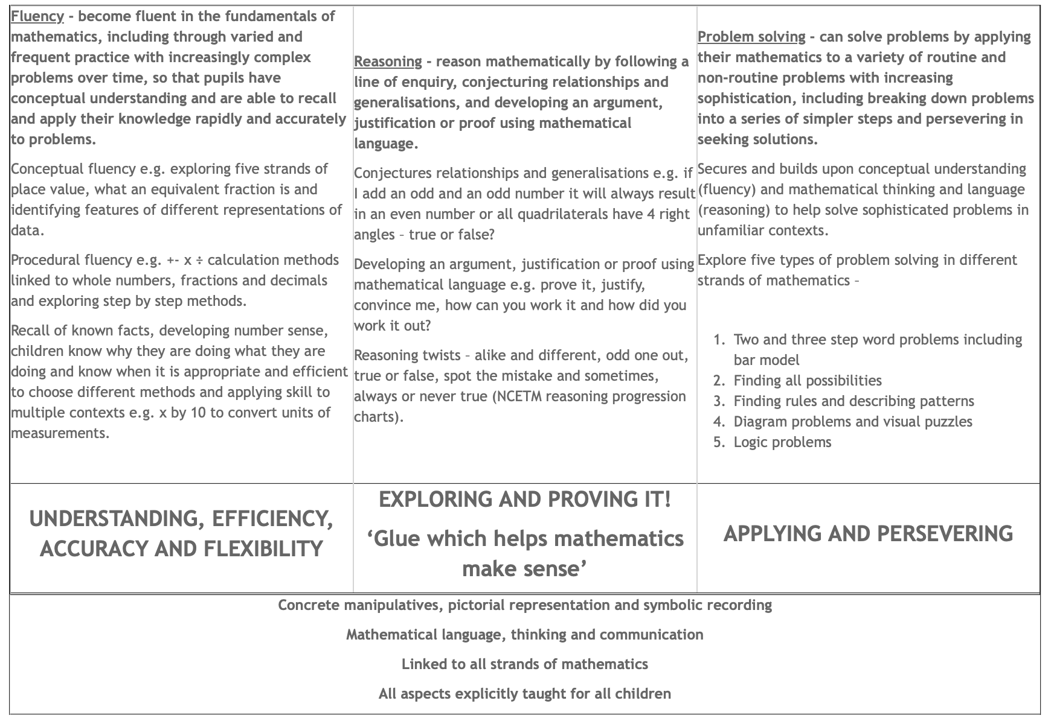

Lesson Structure
We aim to deliver each lesson using our BEACON principles.
B - Bring It Back - children complete Flashback 4 tasks at the start of each lesson and are given feedback on the previous lesson.
E - Explain and Explore - the teacher models, both fluency and reasoning, and questions to maximise the impact of the new learning. As children become more confident the modelling by the teacher leads to paired or independent work, completed on whiteboards our in Journals, to reinforce.
A - Access Amazing Vocabulary - Sentence stems are covered in each lesson. These are stated in the White Rose Maths Schemes of Learning and individual small step overviews.
C - Complete task - Children are given a set of fluency and then reasoning tasks to complete (unless it is a problem-solving session).
O - Own your learning - Children are encouraged to use the “Six Steps to St Aidan’s Success” posters as they work through their tasks as this pushes their independent learning.
N - Check New Learning - during the unit of work the teacher will continue to assess and check on the new learning (see assessment)
Planning
Flashback 4 resources are accessed via the White Rose Maths website. These are put onto sheets, up to 4 days per sheet, for children to access during the ‘Bring It Back’ part of the lesson.
Teachers are encouraged to select tasks from White Rose Maths, both the worksheets and from the Scheme of Learning for their particular unit. These should be Key Learning and Fluency and Reasoning for the majority of lessons. Problem Solving tasks can be selected from the same resources for those lessons where problem solving is being taught.
White Rose Maths teaching slides are then adapted to ensure the concepts within the tasks selected are taught sufficiently.
SEND
Children with SEND, with the support of a TA wherever possible to access the whole class teaching. Their tasks are then differentiated and may be taken from a different year group, linked as closely as possible to the whole class learning.
Resources
Each classroom as a “Choose To Use” area where manipulative (such as Dienes, place value counters, place value grids, 100 squares etc. are kept. Children are encouraged to access this as and when they need to in order to ‘Complete Task’ and ‘Own Your Learning’ A central Mathematics store is outside the Year 6 classroom and its being added to when needed. Teachers are encouraged to take (and return) equipment suitable for their unit of work.
Each classroom has a working wall where current learning may be reinforced with posters etc. that children can access to “Own Your Learning” It should also contain a voting station - this is part of the Bring It Back section of the Beacon Principles.
There are also ‘conjecture’ style posters that are discussed and changed as appropriate. These may be Prove It, True or False, Am I right?, Convince Me style statements with an intention to further reinforce reasoning skills.
Teachers can also access progression documents and calculation policies/progressions via the school website.

CPD
Teachers have access to Mathematics courses through the LA. White Rose Maths also provide CPD for each unit of work if teachers and TAs feel they need further support to reinforce new learning.

Assessment
Feedback will be given in line with schools Feedback Policy which encourages instant feedback during lessons and whole class feedback at the start of the subsequent lesson.
Assessment trackers are maintained throughout the year. Each objective is assessed through classwork and unit assessment tests and each child is rated for each objective covered on a 1-3 system. 1 - some evidence, but not yet secure; 2 - objective is secured; 3 - working at greater depth.
At the end of each term children from Year 2 upwards (Year 1 in the Summer Term) will sit standardised tests in arithmetic and problem solving. These tests are based on the end of year objectives and are designed to be able to show progress across the year as well as comparable scores in other core areas.
Each child is then given a score from 0 - 6 for the subject at the end of each term throughout the year. 0 - below age-related expectations; 1 - emerging, 2 developing (working towards the age related expectation); 3 - progressing, 4 - secure (working at the age related expectation); 5 - exceeding, 6 exceeding with greater depth (working beyond the age related expectation). The aim is for every child to achieve 3 or 4 in every subject at the end of the year.
Homework
Children are encouraged to complete Mathematics homework regularly over the week. Every child from Year 2 upwards has a Times Table RockStars login and every pupil from Year 1 upwards has a MyMaths login. Class pages on the school website links to the two applications and teachers can set tasks as and when appropriate (aiming for at least one MyMaths task a week from Year 2 upwards).

Monitoring
Monitoring is completed via Learning Walks, a look through children’s books and pupil voice. Data is also tracked in Pupil Progress meetings and by the Mathematics Subject Lead on our Insight Tracking system. Governors are also regularly updated about Mathematics in Curriculum Committee meetings.

IMPACT
Children talk enthusiastically about their Mathematics lessons and speak about how they love learning about Mathematics. They can articulate the context in which Mathematics is being taught and relate this to real life purposes. Pupils know how and why Mathematics is used in the outside world and in the workplace. They know about different ways that Mathematics can be used to support their future potential. Pupils use acquired vocabulary in Mathematics lessons. They have the skills to use methods independently and show resilience when tackling problems and they are fluent and accurate when using calculations to solve these problems. Attainment will remain high and progress will be at or above the expected norms.

