LO: Can I determine the strengths and limitations of different sources?
Understand that no single source of evidence gives the full answer to questions about the past.

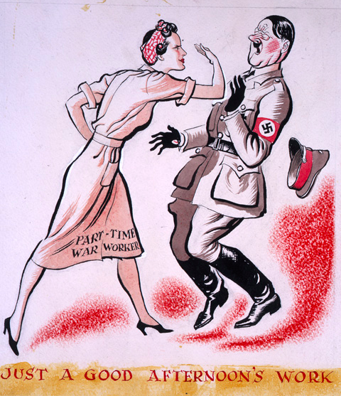
Task 2

You now have to submit your findings to the government.

Which source is the most useful for information about life in Britain during World War II and why?
___________________________________________________________________________________________
___________________________________________________________________________________________
___________________________________________________________________________________________
___________________________________________________________________________________________

Which source is the worst for information about life in Britain during World War II and why?
___________________________________________________________________________________________
___________________________________________________________________________________________
___________________________________________________________________________________________
___________________________________________________________________________________________

