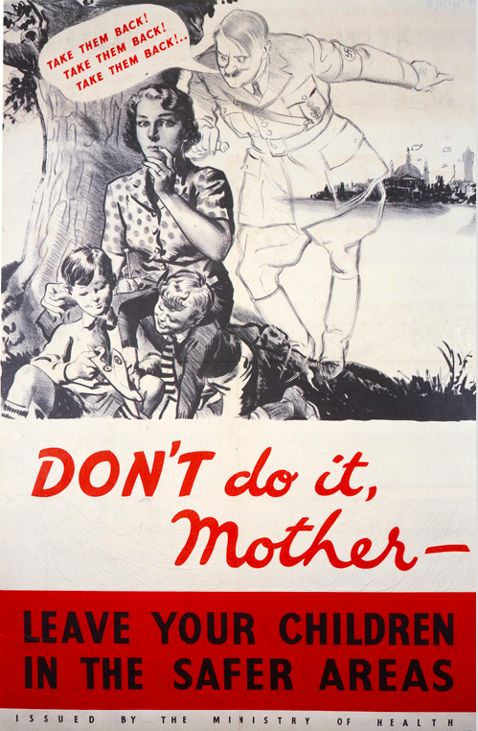
Source 1- Government propaganda to encourage evacuation (1943)

