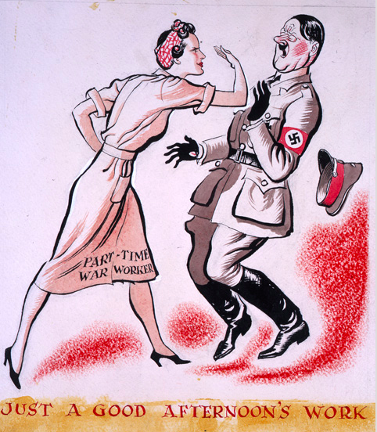
Advertisement poster in a pro-war magazine (1943)

