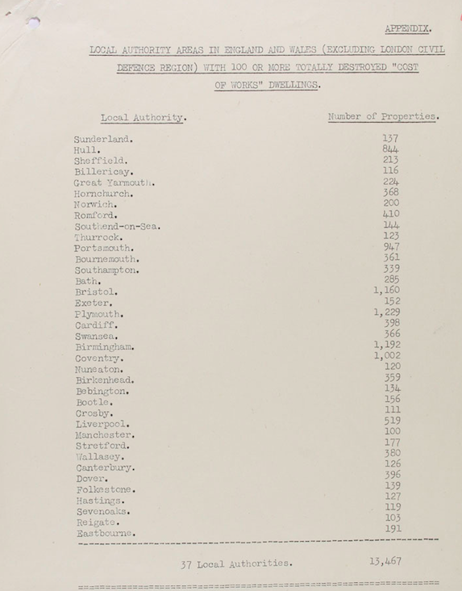
Source 3- Government report on number of houses bombed in England (1945)

