What to do today
IMPORTANT Parent or Carer – Read this page with your child and check that you are happy with what they have to do and any weblinks or use of internet.

1. Read a blog post
- Read the blog post: 10 Naughty things that dogs do
- Which of these things would you say is the naughtiest? Which would you say is the least naughty? Which do you think is the most amusingly described? Why?

2. Revise active and passive voice
- Use the Revision Card to remind yourself about how the active and passive voice are constructed and used.
- Complete Active to Passive/Informal to Formal. Write sentences in the passive voice and think of more formal synonyms for some informal vocabulary.

3. Now for some writing
- Re-write one of the paragraphs from the 10 Naughty Things blogpost much more formally. Change active to passive and use more formal vocabulary.
- Read the Example to see how this might sound.

Well done. Share your writing with a grown-up. Show them the formal vocabulary used and any sentences written in the passive voice.

Try the Fun-Time Extra
- Can you write a new blog post about naughty things a different pet does? Can you write it in an informal style with informal vocabulary and active voice sentences?

10 Naughty Things That Dogs Do
Dogs do so many naughty things. All dog owners understand some of the most devious things that dogs like to do. Some of them are done intentionally and others just because they seem fun. When you return home and your dog displays their ‘guilty’ face you know they have probably done something wrong. Dogs can get up to all sorts of mischief yet,
at the end of the day, we still manage to love them.

It’s difficult to resist those puppy dog eyes, even when they have done something really bad. Perhaps there is something that your dog does that really frustrates you. Feel free to share your funny stories below. Here are some very naughty things that dogs often do at least once in their lifetime.

1. Get into the bins
Come home from work and it looks like the rubbish men have tipped the entire street’s rubbish into your kitchen? Yep, your dog has probably got into the bins and had a huge feast. In the process they have spread rubbish all over your kitchen.
One of the worst things about your dog getting into the rubbish is worrying about what they might have eaten. If you are really unlucky they will get a funny tummy from eating things they really shouldn’t have. If this happens it’s probably best to invest in a doggy proof bin.

2. Destroy the sofa
Just bought a brand-new sofa? It’s just too tempting for some dogs to resist. Especially puppies who just love to chew anything in sight. Many dog owners can understand the frustration of coming home to a sofa that is completely destroyed.

3. Poop on the carpet
OK, so even the best toilet trained dogs can occasionally have an accident. If you own a dog they will probably poop on the carpet at some point in their lives. Whether it’s when they are a pup and haven’t quite mastered the whole going to the loo outside thing or when they are older and just can’t hold it in.

4. Escape
Some dogs are cunning escape artists. No matter what you do they will figure out a way to escape. Then you have to go searching around the neighbourhood or they eventually come home after a nice little adventure. If your pooch loves to run away then make sure you have high fences and a completely enclosed garden to stop them from getting out.

5. Completely ignore owner
So you spend years teaching your dog how to behave properly and teach them all the important commands. Yet some days they simply just ignore you. You know they know exactly what you want them to do but they choose denial.

6. Make a scene in public
Has your dog ever made a scene in public? Jumped into a swimming pool, barked really loudly around lots of people or pooped in a really awkward place? It can be very stressful if you take your dog out and they decide to embarrass you in public.

7. Chase after things (birds, rabbits, bikes, people, squirrels, deer)
The chase instinct is probably one of the hardest things to train dogs to ignore. Some dogs in particular such as sighthounds have an extremely strong chase instinct that you may never be able to prevent. It’s in their DNA to chase things. However, it is really frustrating when you are out and about and your dog suddenly decides to chase something interesting and you spend ages running after them.

8. Bark all day long
Have you ever had a day where your dog just won’t be quiet? Something has set them off and they spend the entire day barking at the smallest things. This can be very frustrating and also not very pleasant for your neighbours!

9. Pee round friend’s houses
You decide it is now safe, you have spent long enough toilet training that your dog should be safe to visit a friend’s house. They haven’t peed in your house for months or even years, yet as soon as you set foot in someone else's house they just can’t help peeing all over the carpet.

10. Recall failure
You take your dog on a walk and get to the end of your walking route and your dog decides it’s not time to go yet. They know that you are near the end of the walk so they take themselves off on another sniffing adventure. They don’t run away completely, they stay near you but completely ignore your recall commands until they are ready to go.

http://www.timeforpaws.co.uk/blog/10-naughty-things-dogs/

Active and Passive Voice – Revision Card

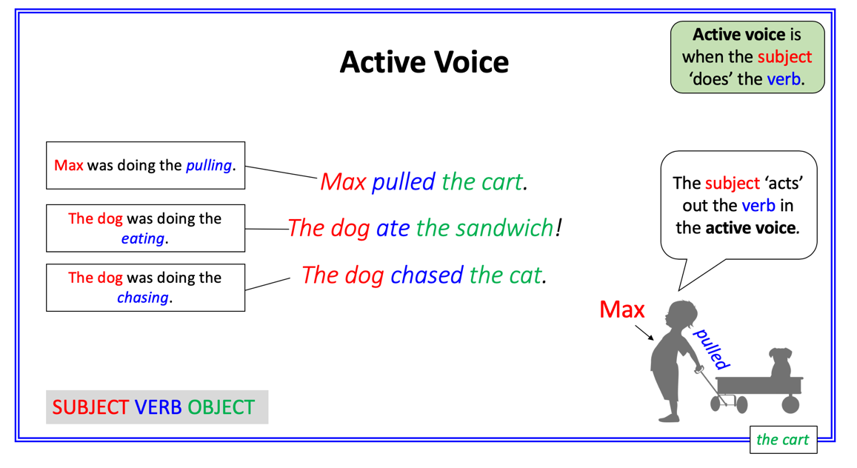 | 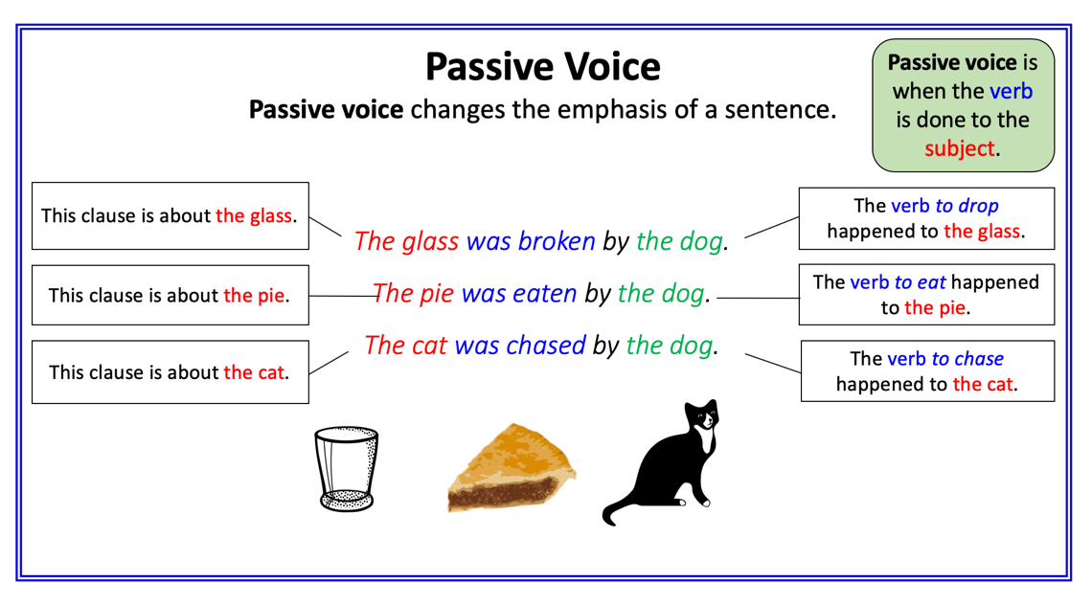
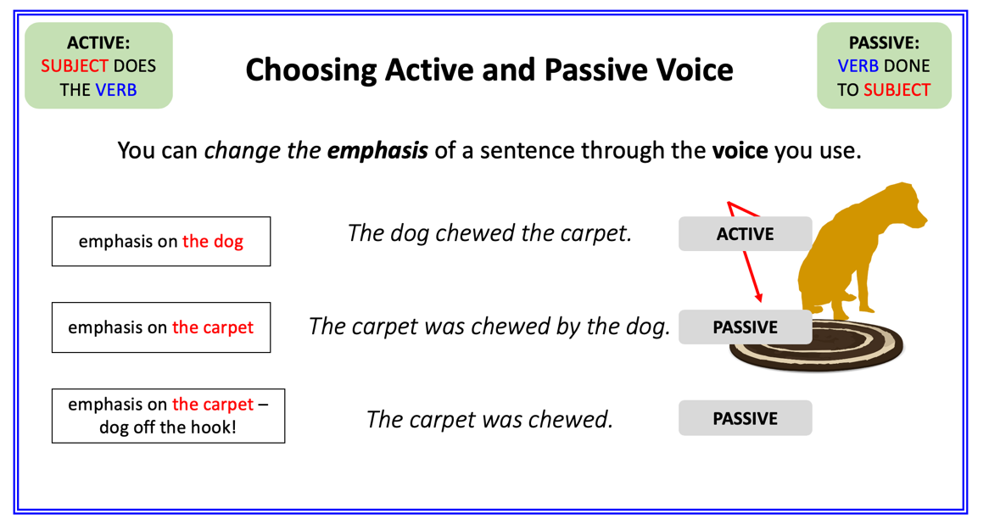 | 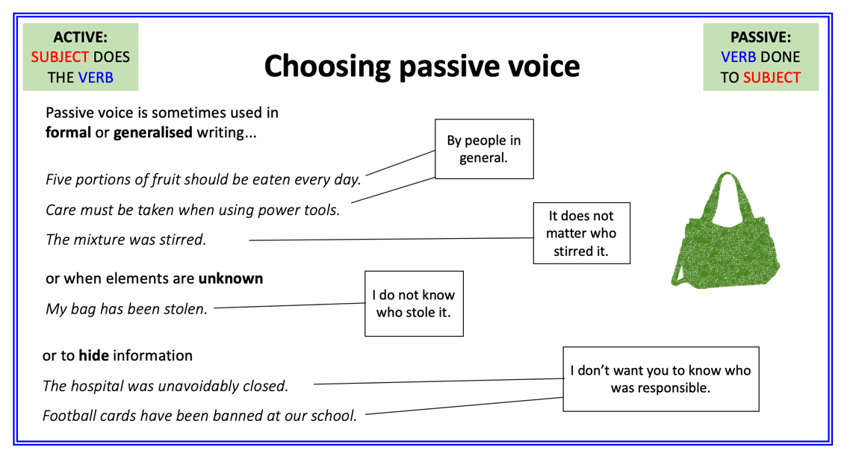

Active to Passive/Formal to Informal

Active Original | Passive version
Someone has tipped the entire street’s rubbish into your kitchen.
Your dog has got into the bins.
He has spread rubbish all over your kitchen.
He will get a funny tummy.
Even the best toilet trained dogs can occasionally have an accident.
You own a dog.
Dogs will find a way to escape.
You have to search around the neighbourhood.

Informal Vocabulary | Formal Alternative
Yep
Funny tummy
Doggy proof
Poop on the carpet
Going to the loo
Cunning escape artists
Figure out a way
Pooch

Example

Original
Dogs do so many naughty things. All dog owners understand some of the most devious things that dogs like to do. Some of them are done intentionally and others just because they seem fun. When you return home and your dog displays their ‘guilty’ face you know they have probably done something wrong. Dogs can get up to all sorts of mischief yet we still manage to love them at the end of the day.

Rewritten
Many naughty things are done by dogs and their devious preferences are often well understood by their owners. Intentional actions are sometimes clear, but other acts can be explained merely by the motivation of ‘fun’. When owners return home and guilty faces are evident, something naughty has undoubtedly occurred. Much mischief is caused by dogs; nonetheless, they are loved by their owners.

Formal Version

Take another paragraph of the 10 Naughty Things blog and re-write it much more formally. Try to use passive voice and formal vocabulary.

