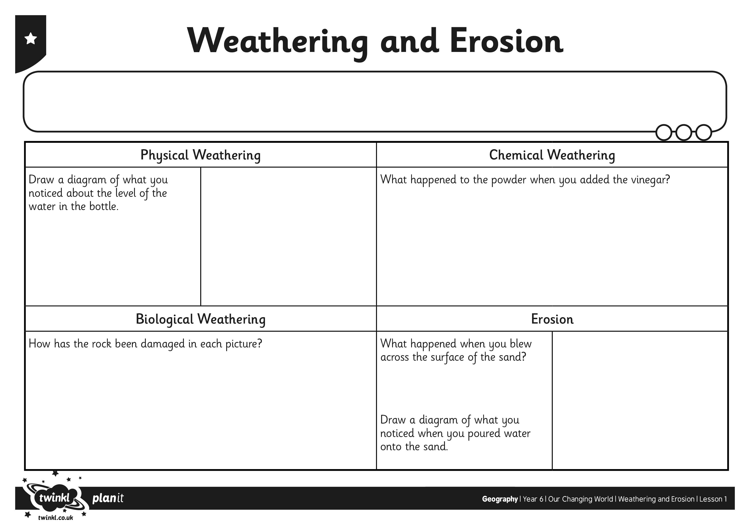
I can explain how erosion and weathering can change the landscape.

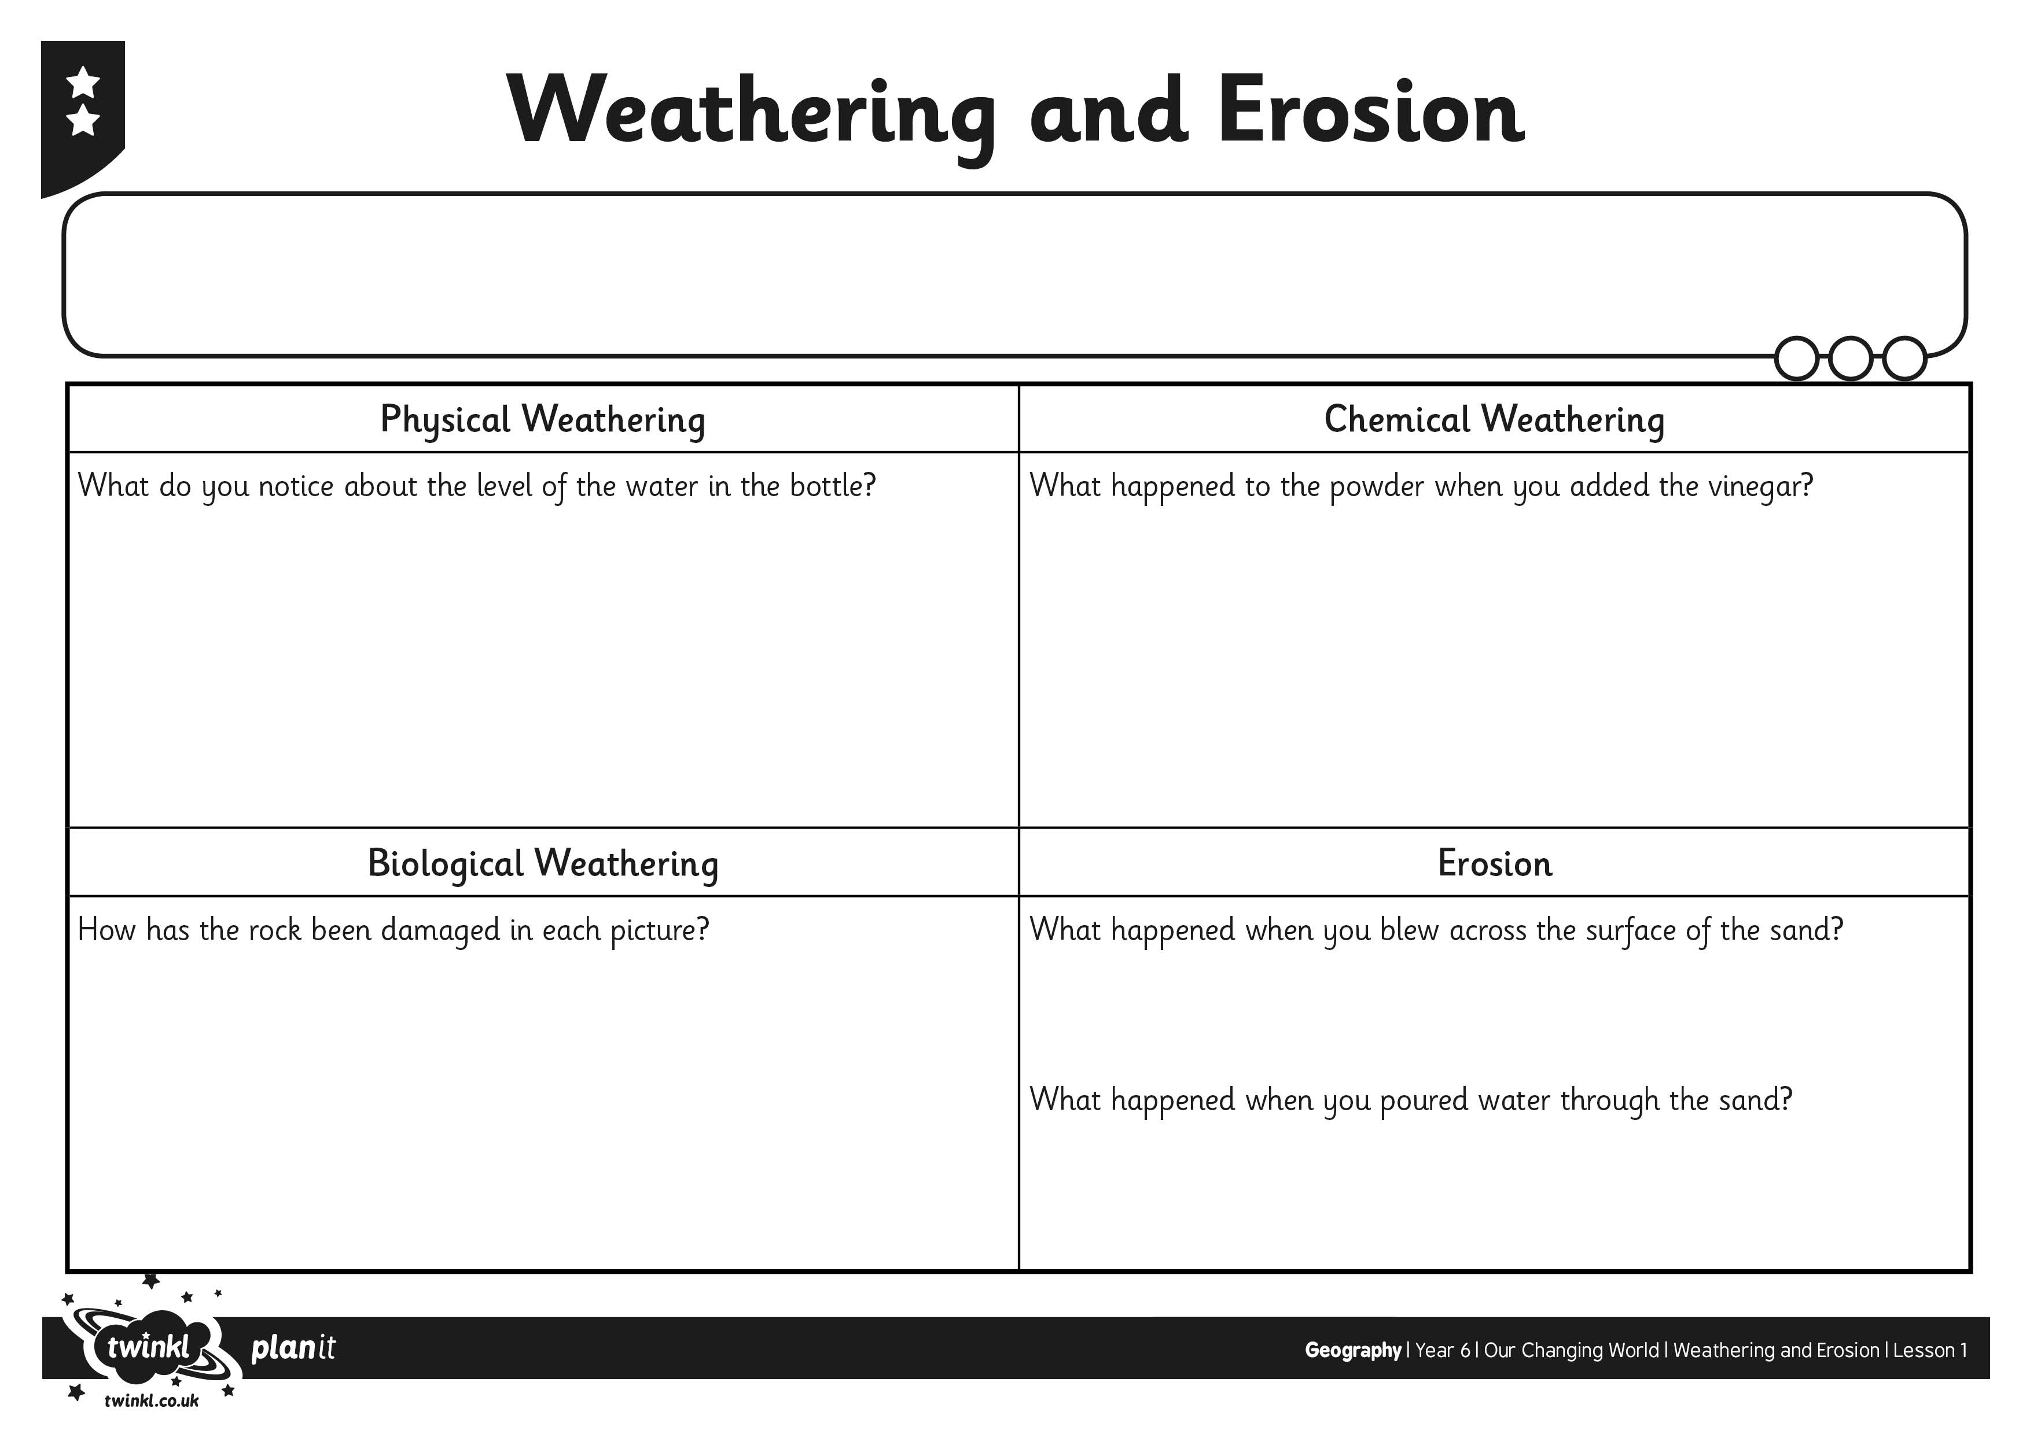
I can explain how erosion and weathering can change the landscape.

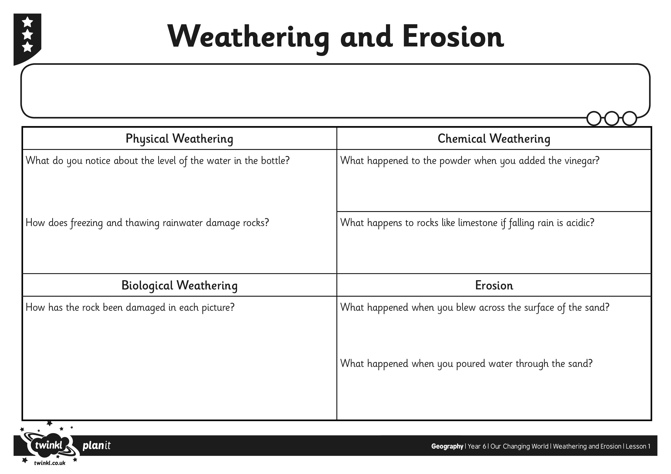
I can explain how erosion and weathering can change the landscape.

