**What to do today**

*IMPORTANT Parent or Carer – Read this page with your child and check that you are happy with what they have to do and any weblinks or use of internet.*

**1. Read a blog post**

* Read about *Lizzie Greenwood* and *Day 13 Diary.*
* Highlight some of the features of informal writing that you can find in this blog post.

**2. Revise verbs**

* Use the ***PowerPoint*** *on**clauses and conjunctions* and listen to the teaching. If this is not possible, remind yourself about these using the *Revision Card* below.
* Complete *Antarctic Clauses and Conjunctions*.

Explain your answers to a grown-up. Explain what a main and a subordinate clause are. You can check your answers at the end of the pack.

**3. Now for some writing**

* Write sentences about a place that you would like to visit. Is it cold or hot? Wild or urban? Describe what you know about it and why you would like to travel there.
* Share your sentences with someone else. Show them the coordinating and subordinating conjunctions that you have used.

**Try the Fun-Time Extras**

* Can you find out more about Antarctica? What else might Lizzie have seen or experienced while she was there.
* Find out more about a place that you would like to visit. Can you write a blog diary entry imagining that you are there?

***Lizzie Greenwood: Biography and Background***

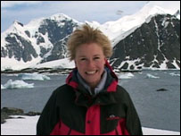

Lizzie Greenwood (now Lizzie Greenwood-Hughes, following her marriage to Welsh rugby star, Geraint Hughes) is a journalist and TV sports commentator.

Between 2001 and 2005 she was the presenter of *Newsround* on BBC1 and, as part of her work on the show, travelled to Antarctica in 2003. *Newsround* wanted to produce an extra show looking at the impact of global warming on the environment.

Lizzie kept a diary of her adventures at the South Pole and this was posted as a blog on the *Newsround* website throughout her stay.

***Lizzie Greenwood’s Diary–Day 13***

Day 13: Friday 12 December 2003

Everyone reckons we brought the beautiful weather with us when we arrived in Antarctica. Since we stepped off the little red plane 10 days ago, the sun has been beating down on Rothera. This place is fast becoming the Antarctic Costa del Sol!

It is generally good news for everyone. The pilots can happily fly their planes to far-flung research sites, the divers can take their boats on the mill pond-like sea and Paul and I can get a great tan while we film the amazing landscape.

Today I have been interviewing Adam who is one of the meteorologists or weathermen (a kind of Antarctic John Ketley, but much younger and without the beard).

Part of his work is to find out what's going on in the earth's upper atmosphere. So three times a week he blows-up a massive balloon, attaches a sensor to it from a bit of string and then lets it go.

The sensor sends back information to Adam's computer which then tells him what the temperature, humidity and wind is like up in the atmosphere. Apparently the balloon gets bigger as it goes up, ending-up the size of two double decker buses before it eventually pops.

Every day a radio communications operator gets in touch with all the people who are working away from Rothera. There are scientists dotted all over the place, miles from anywhere so it is important that the people here know that everyone is safe.

Radios are the main way for people to keep in touch if they are off base and often people accidentally use radio phrases even when they are talking face to face.

For example, when I was interviewing a biologist called Mairi she finished one of her sentences with 'over and out' which really made me giggle.

I still haven't been snowboarding, but when I do, you can be sure that will be my picture of the day.

Today's photo is of Paul because his sister complained they were all of me! So here is Paul, my producer, while he was co-piloting the Twin Otter plane – just for you Clare Arnold.

*Lizzie, 'over and out', in the Antarctic.*

**Revision Card – Clauses and Conjunctions**

|  |  |
| --- | --- |
|  |  |
|  |  |

**Antarctic Clauses and Conjunctions**

1. Is the writing in **bold** in the sentences below a clause or phrase? Tick the correct box.

|  |  |  |
| --- | --- | --- |
|  | **Clause** | **Phrase** |
| **I ran down the slope** towards Rothera Base Camp. |  |  |
| Inside the building **it was warm and welcoming.** |  |  |
| I heard a crashing sound **inside the kitchen.** |  |  |
| **The chef had dropped our dinner** all over the floor! |  |  |
| **Quick as a flash,** I rushed to help clear up. |  |  |

2. Highlight the **conjunctions** in these sentences.

1. The weather balloon quickly filled up and floated away into the blue Antarctic sky.
2. I was keen to talk to the scientists but Paul wanted to film the seal pups before lunch.
3. The pups need constant attention from their mother, as they have to be kept warm in the biting wind.
4. They look safe enough, although I have been told there is a storm coming in.
5. When it does, the seals will head into the water or huddle together for safety.
6. We will be tucked up inside the Base since our coats are nowhere near as thick as those of the seals!

3. The conjunctions you have identified in the sentences above are either **co-ordinating conjunctions** or **subordinating conjunctions**. Sort them into the two columns.

|  |  |
| --- | --- |
| **Co-ordinating conjunctions** | **Subordinating conjunctions** |
|  |  |
|  |  |
|  |  |
|  |  |
|  |  |

4. Is the writing in **bold** in the sentences below a main clause or a subordinate clause?

|  |  |  |
| --- | --- | --- |
|  | **Main** | **Subordinate** |
| **The Twin Otter’s engines roared,** although I could hear very little with my headphones on. |  |  |
| **We headed out over the icy hillside** and looked down on the scientists at work below. |  |  |
| I knew I was going home in just a few weeks, **whereas** **many of the scientists stay at Rothera for months.** |  |  |
| **Because we were coming close to the end of our trip**, I wanted to take as many photographs as possible. |  |  |
| I tried to steady my camera **but the plane’s shaking made it wobble too much for a shot.** |  |  |

**Using Conjunctions**

Use the conjunctions from the box below to write sentences about a place you would like to visit. Is it cold or hot? Wild or urban? Why would you like to travel there?

How many conjunctions can you use?

|  |
| --- |
| although since while whereas because until when as  until before even if though after wherever yet |

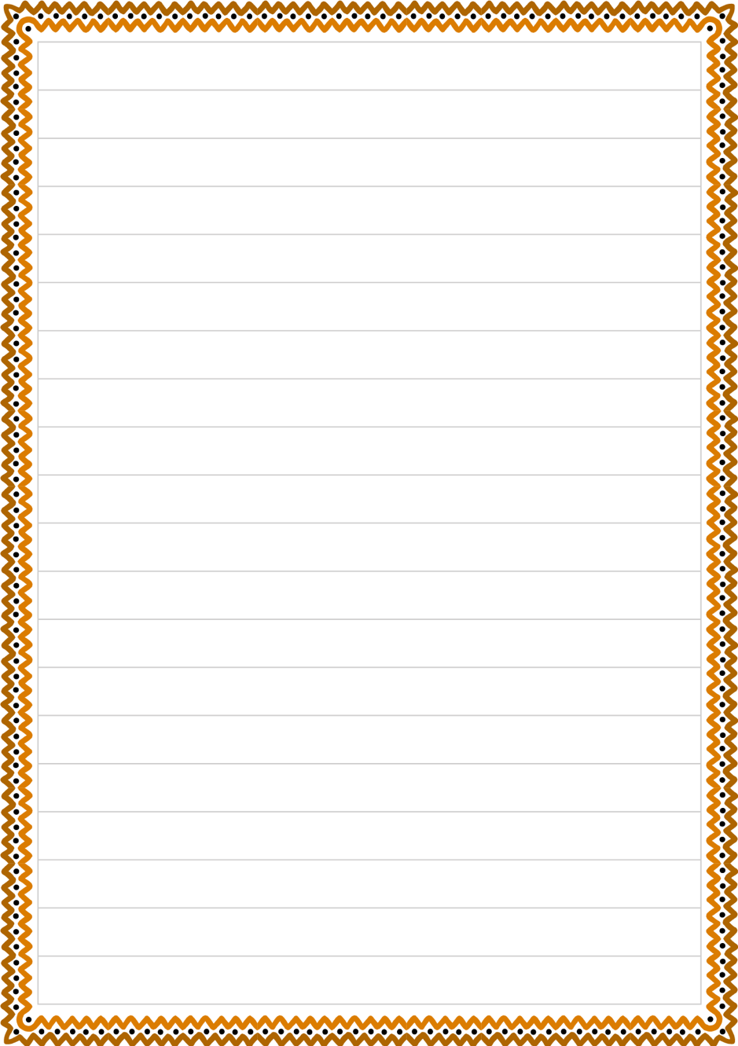

**Antarctic Clauses and Conjunctions - ANSWERS**

1. Is the writing in **bold** in the sentences below a clause or phrase? Tick the correct box.

|  |  |  |
| --- | --- | --- |
|  | **Clause** | **Phrase** |
| **I ran down the slope** towards Rothera Base Camp. | X |  |
| Inside the building **it was warm and welcoming.** | X |  |
| I heard a crashing sound **inside the kitchen.** |  | X |
| **The chef had dropped our dinner** all over the floor! | X |  |
| **Quick as a flash,** I rushed to help clear up. |  | X |

2. Highlight the **conjunctions** in these sentences.

1. The weather balloon quickly filled up and floated away into the blue Antarctic sky.
2. I was keen to talk to the scientists but Paul wanted to film the seal pups before lunch.
3. The pups need constant attention from their mother, as they have to be kept warm in the biting wind.
4. They look safe enough, although I have been told there is a storm coming in.
5. When it does, the seals will head into the water or huddle together for safety.
6. We will be tucked up inside the Base since our coats are nowhere near as thick as those of the seals!

3. The conjunctions you have identified in the sentences above are either **co-ordinating conjunctions** or **subordinating conjunctions**. Sort them into the two columns.

|  |  |
| --- | --- |
| **Co-ordinating conjunctions** | **Subordinating conjunctions** |
| and | as |
| but | although |
|  | when |
|  | since |

4. Is the writing in **bold** in the sentences below a main clause or a subordinate clause?

|  |  |  |
| --- | --- | --- |
|  | **Main** | **Subordinate** |
| **The Twin Otter’s engines roared,** although I could hear very little with my headphones on. | X |  |
| **We headed out over the icy hillside** and looked down on the scientists at work below. | X |  |
| I knew I was going home in just a few weeks, **whereas** **many of the scientists stay at Rothera for months.** |  | X |
| **Because we were coming close to the end of our trip**, I wanted to take as many photographs as possible. |  | X |
| I tried to steady my camera **but the plane’s shaking made it wobble too much for a shot.** | X |  |