What to do today
IMPORTANT Parent or Carer – Read this page with your child and check that you are happy with what they have to do and any weblinks or use of internet.

1. Read a set of instructions
- Read Toast Instructions 1
- What do you think is good about these instructions? Is there anything that could be improved?
- Read Instructions Features. Annotate and mark the text to show some of these features.

2. Looks for features in sets of instructions
- Fill in Instruction Checklist for Toast Instructions 1.
- Now read Toast Instructions 1 and 2 and fill in Instructions Checklist.
- You could challenge yourself to read Toast Instructions 3 and to fill in the checklist for this article as well.

3. Now for some writing
- Write your own set of instructions about something that you know well.
- It could be another piece of cooking, a sport or video-game, music, art or anything at all. Use Instruction Features to help you as you write.

Well done! Share your writing with a grown-up. Show them the features that you have included.

Try the Fun-Time Extras
- Can you find a recipe that you could try out at home?
- Can you learn a new skill with instructions from a book or the internet? You could use www.wikihow.com . Who could you share your new skill with?

Toast Instructions 1 - Delia Recipe

Ingredients  Brown or white bread, cut 1cm thick  Equipment  A sharp serrated knife | 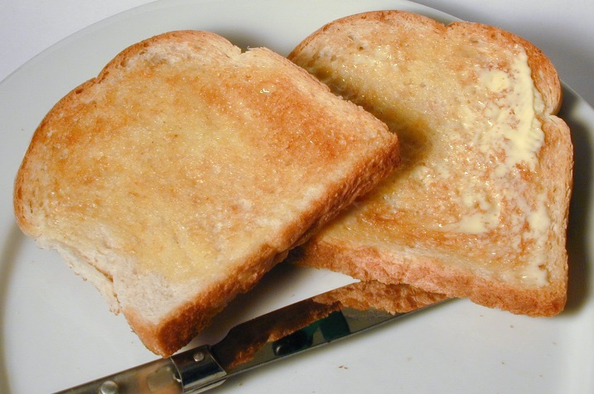
Method
The key to slicing bread is to cut it using a sharp serrated knife. Use gentle, rapid sawing movements and do not to push down too hard on the loaf.

For toast, cut the bread into slices about 1cm thickness. The crusts can be on or off, depending on how you like them. Pre-heat the grill for at least 10 minutes before making the toast, turning it to its highest setting. Place the bread on the grill rack and position the tray 10cm from the heat source. Allow the bread to toast on both sides to pale or dark golden brown.

While that’s happening, keep an eye on it and don’t wander far away. When the toast is done, remove it immediately to a toast rack. Why a toast rack? Because they are a brilliant invention. Freshly made toast contains steam, and if you place it upright, with the air circulating, the steam escapes and the toast becomes crisp and crunchy. Putting it straight on to a plate means the steam is trapped underneath, making it damp and soggy.

Always eat toast as soon as possible after that, and never make it ahead of time. Never ever wrap it in a napkin or cover it (the cardinal sin of the catering trade), because the steam gets trapped and the toast goes soggy. Always use good bread, because the better the bread the better the toast. It is also preferable if the bread is a couple of days old.

from: https://www.deliaonline.com/recipes/type-of-dish/bread-recipes/perfect-toast

Instruction Features

Purpose – tells how to do or make something

Range – Non-fiction book, recipe, science experiment, instruction on packaging, poster or sign, manual, craft patterns.

- Title which says what will be achieved
- List of ingredients or equipment needed
- Step by step actions
- Labelled illustrations
- Bullet points or numbered lists
- Clear, concise vocabulary and sentence structures
- Present-tense imperative verbs (e.g. Mix the flour, Cut along the line, Press the controller)
- Clear statements of quantities, measurement and other details
- Descriptive language used for clarity rather than vividness or effect
- Adverbials (numbers or time connectives) used to show stages in a process

Instructions Checklist
 | 1 | 2 | 3 | 4
Title which says what will be achieved
List of ingredients or equipment needed
Step by step actions
Labelled illustrations
Bullet points or numbered lists
Clear, concise vocabulary and sentence structures
Imperative verbs (e.g. Mix the flour, Cut along the line, Press the controller)
Clear statements of quantities, measurement and other details
Descriptive language used for clarity rather than vividness or effect
Adverbials (numbers or time connectives) used to show stages in a process

Toast Instructions 2 - Jamie Oliver Recipe
Toast is wonderful, humble food. Some people think toast is just toast – but not in my house. There are a million options. How about toast on a barbecue, where the smokiness takes it to a new level? We all like Marmite in our family, but sometimes I have a ripe tomato and a bit of salt on toast. In the past, I have turned the toaster on its side, put cheese on bread and slid it in so it toasts on one side and melts on the other. It’s a bit of a jiggle but it works. There is a divide in our family about how to make toast on an Aga. My Mrs likes to put the bread on the hot side in an Aga toaster, so you get funny little white lines – pointless, in my opinion. I put the bread on the cooler side so it gets super crispy. But my favourite way of making toast is in a frying pan. Here’s how:
1. Sourdough, which is spongy, toasts up a treat. It stays fresh for a week and then you can grill it for bruschetta or dry it out for what the Italians call pangritata to liven up stews, soups and salads. We waste about 40% of bread in Britain but once you’ve tasted pangritata you’ll never throw bread away again. Put a slice in a hot, dry non-stick pan and cook for a minute and a half on each side or until golden and crisp. I do it by smell – the equivalent of roasting coffee beans. Press the bread down with a flat bottle.
2. After I’ve toasted one side, I like to turn it over and put something heavy on the bread – try a bottle of HP sauce – to squash it flat. It ensures the entire surface area is toasted for maximum crunch.  Make sure your butter is at room temperature.  3. Get the butter or marg on straight away. I am a butter person and really good butter is always a pleasure. Make sure it is at room temperature – it’s a pain if your toast goes cold while you’re trying to spread it. | 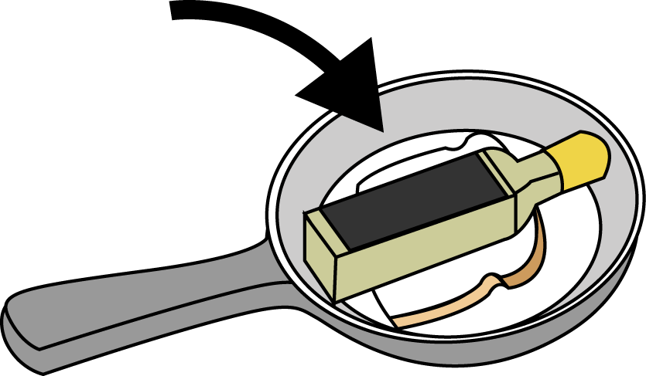  .

Then your toast awaits your next embellishment: a nice bit of jam or Marmite.

4. How I cut toast depends on my mood. I like soldiers if I am nostalgic or have an egg to dip into. Cutting toast into rectangles is belt and braces when I am in a rush. But if I want to be more upmarket, I’ll cut it into triangles. I don’t cut off the crusts because a) it’s a waste and b) most of the nutrients of any bread are in the crust. Plus, I like the contrast of the soft and the crunchy bits, but, if you want to be wussy, you can cut ’em off.

From: https://www.theguardian.com/lifeandstyle/2015/jan/09/how-to-make-toast-the-jamie-oliver-way

Toast Instructions 3 - How To Make Perfect Toast

Scientists revealed the mathematical formula for a perfect slice of toast, showing that it is best cooked for exactly 216 seconds.
A team of researchers carried out a study which found the optimum thickness is 14mm and the ideal amount of butter is 0.44 grams per square inch.
The recommended cooking time gives the slice a 'golden-brown' colour and the 'ultimate balance of external crunch and internal softness'.
It has the look of 'builder's tea' and, crucially, the outside is 12 times crunchier than the middle.
The result is achieved by setting the toaster dial to 'five out of six' on a typical 900-watt appliance to produce a temperature of 154 degrees Celsius, the study revealed.
Bread expert Dr Dom Lane, a consultant food researcher, spent one week toasting and tasting a staggering 2,000 slices for his research, in his bid to assist the nation's toast eaters.
During his exhaustive study, commissioned by bread maker Vogel's, Dr Lane used a complex formula to help determine the toasting required to produce the perfect level of crispiness.
He found that 216 seconds was the exact amount of time needed to toast the outside to the desired level before the golden 12:1 exterior/interior crispiness ratio was lost.
He also discovered it was best to use a pale, seeded, loaf, taken fresh from the fridge at a temperature of 3 degrees Celsius.
Both sides of the bread should be cooked at the same time, using a toaster rather than a grill, to help 'curtail excessive moisture loss'.
It should then be buttered as soon as it pops up, before the slice loses the heat required to melt the spread.
Toast Instructions 4 - How to Cook Toast in an Oven
When you're cooking breakfast for a large family or a large group of people, toast often becomes a problem. Even with a large four-slice toaster, you are often left making many batches of toast or faced with serving people cold pieces. Cooking toast in the oven gives you the ability to make many more pieces at one time, as well as giving you an option should you ever wake up to find your toaster no longer works. Making toast in the oven is not as easy as placing the slices and waiting for the toast to pop. You must keep your eye on the bread at all times.
Step 1  Move the top shelf in your oven to the highest it can go. Set your oven to the low broil setting and allow to heat for 5 to 10 minutes.  Step 2  Place the bread pieces on a baking sheet. Do not worry if the edges of the bread touch, as you are toasting the tops and |  | 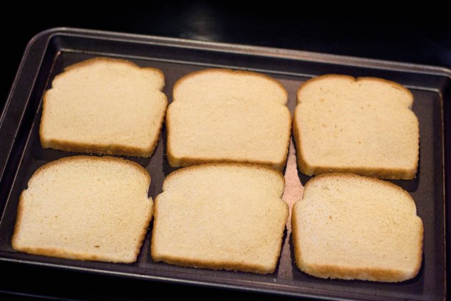
bottoms. If you do not have a baking sheet, or need to toast more pieces than will fit on the baking sheet, you may place the bread directly on the oven shelf.

Step 3
Open the oven and place the baking sheet or bread slices on the top shelf. Leave the oven door slightly open so you can watch the tops of the bread slices. Continue to cook until the bread reaches a golden brown, typically one to four minutes, depending on your oven.

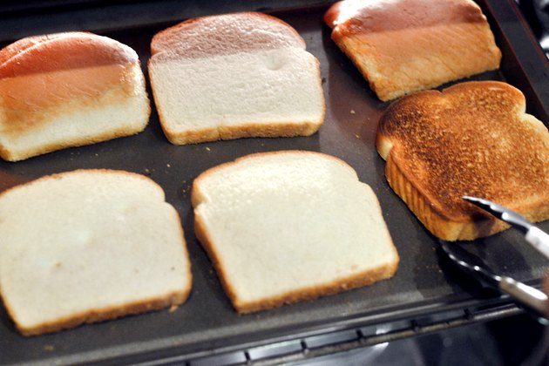 | Step 4  Flip the slices of bread over with tongs and, leaving the oven door slightly open, toast the other side until it reaches a golden brown. Remove the toast from the oven and top with butter or margarine, if you wish.  Warning  Always keep your eye on the bread as it toasts. Bread
burns easily and quickly and a simple turn of the head can be enough to turn your golden brown toast into a lump of black and burnt bread.

Things You'll Need
Baking sheet (optional)
Tongs
Butter or margarine (optional)
Knife (optional)

Write your own Instructions

