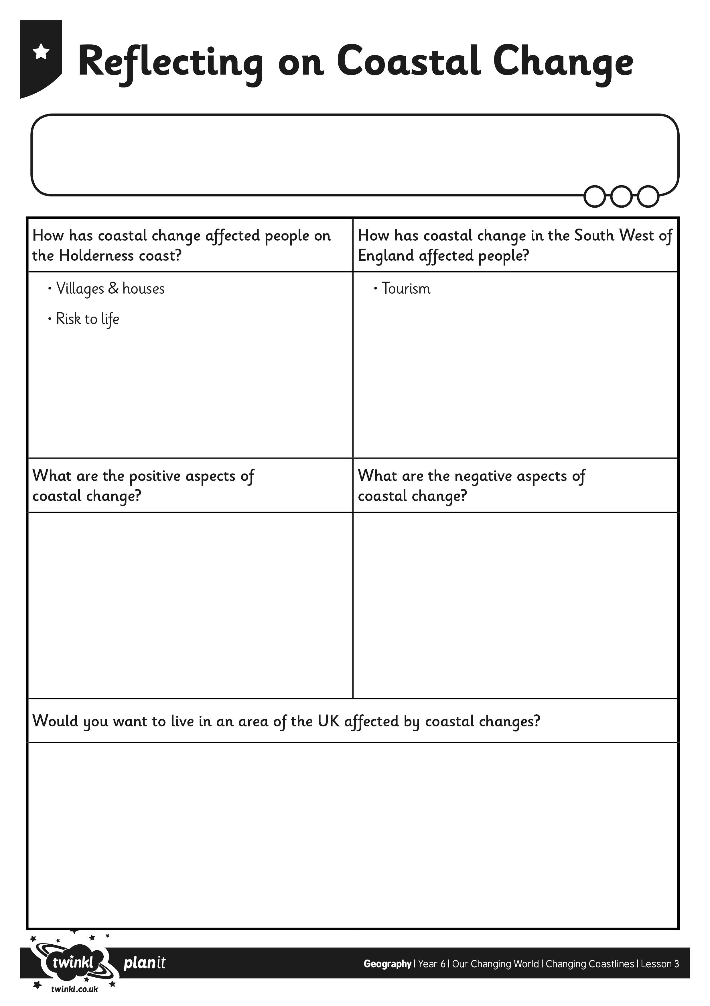
I can explain how water and weather can change coastlines.
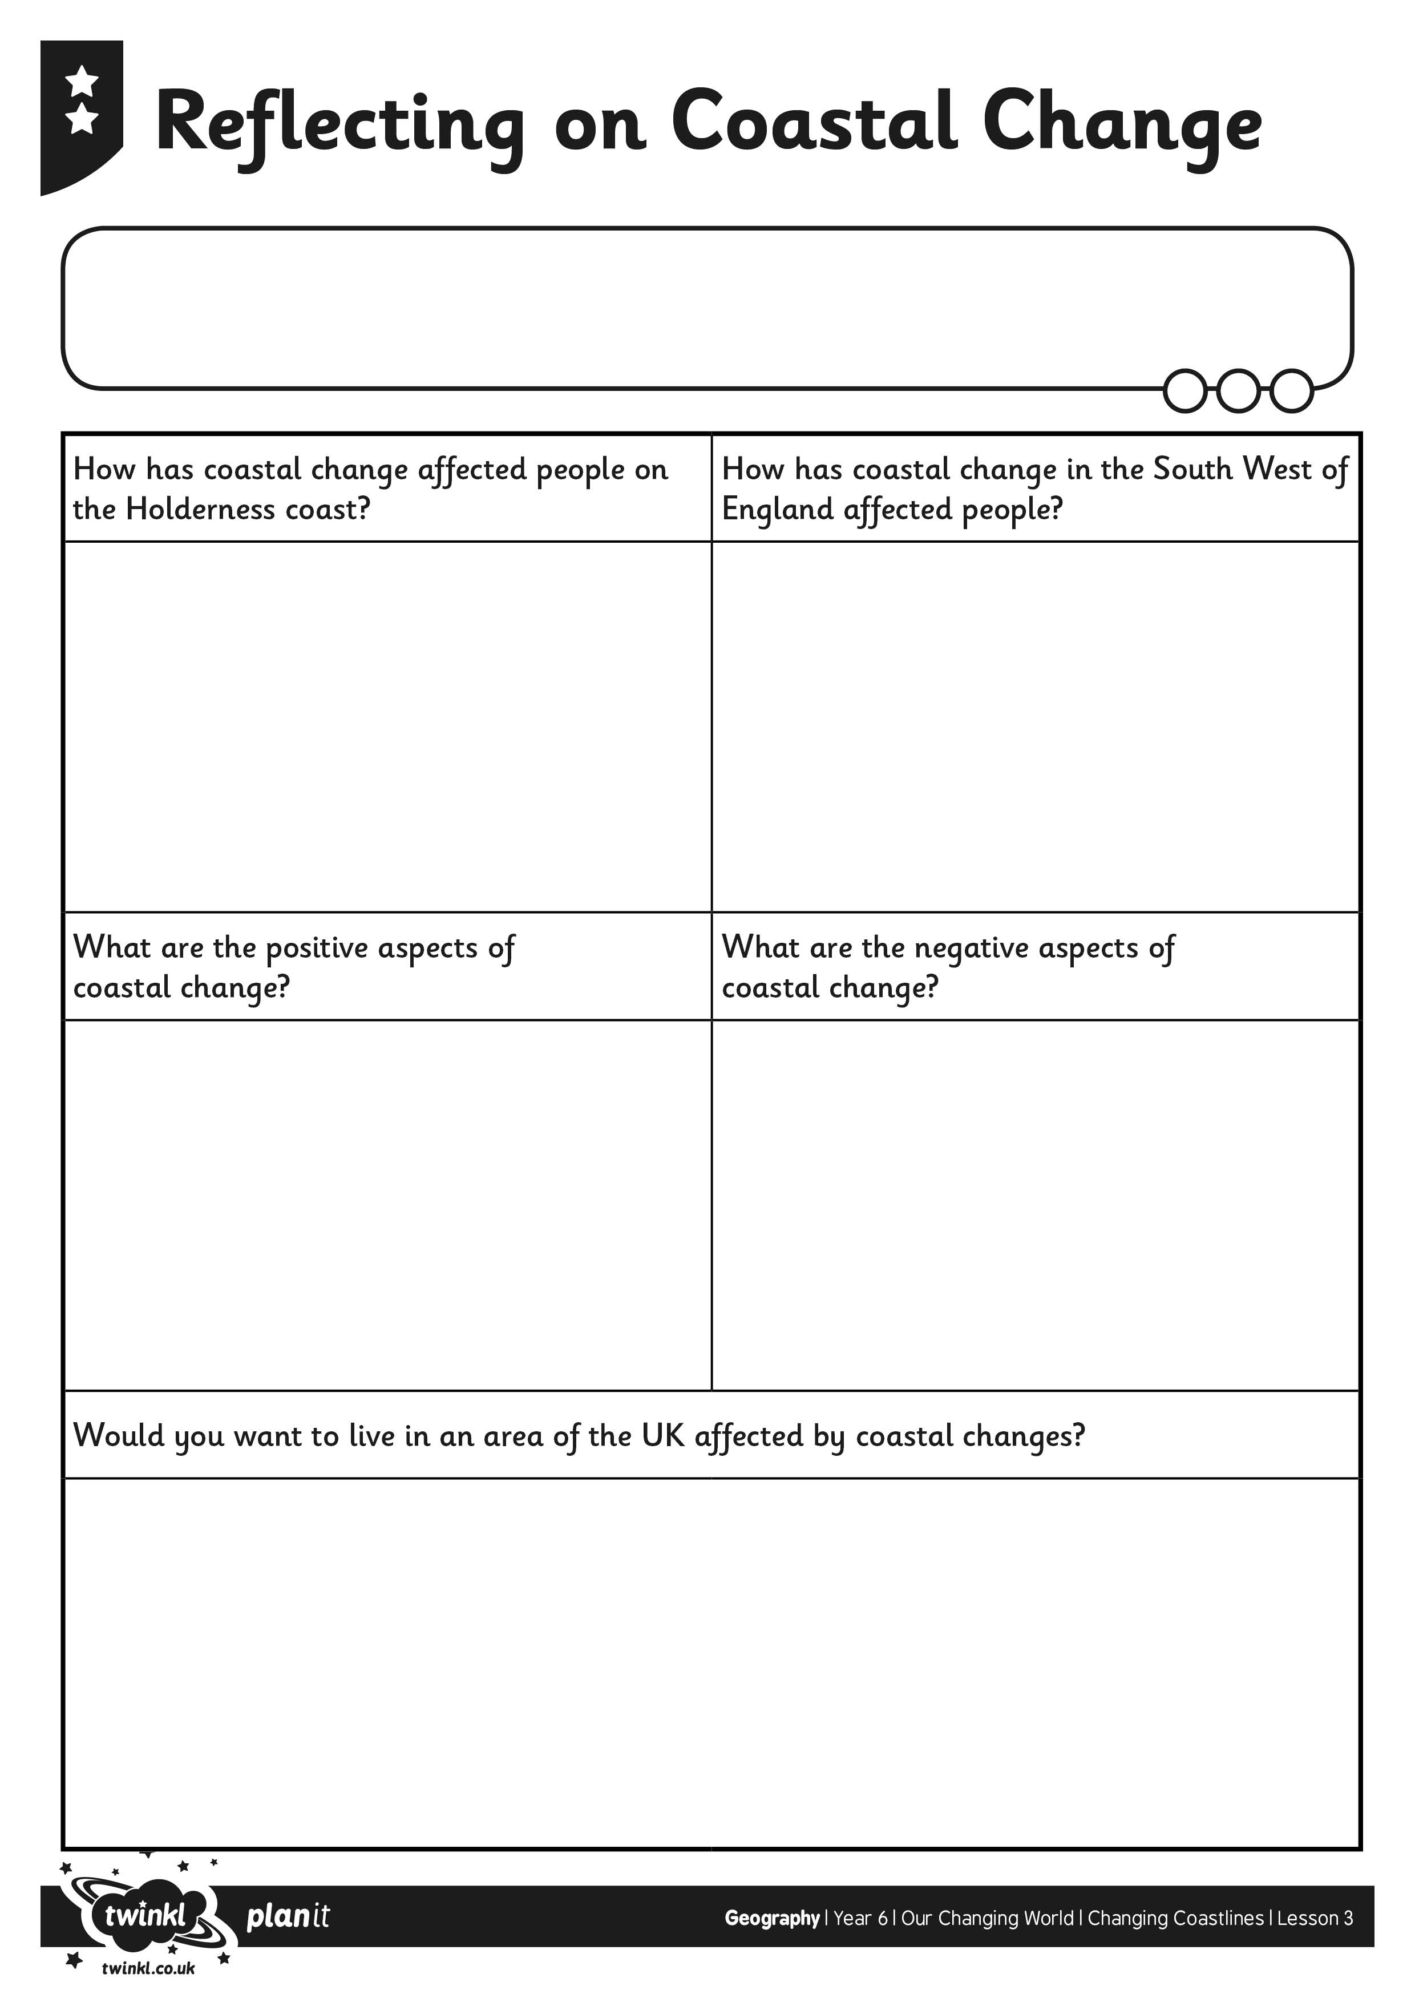
I can explain how water and weather can change coastlines.
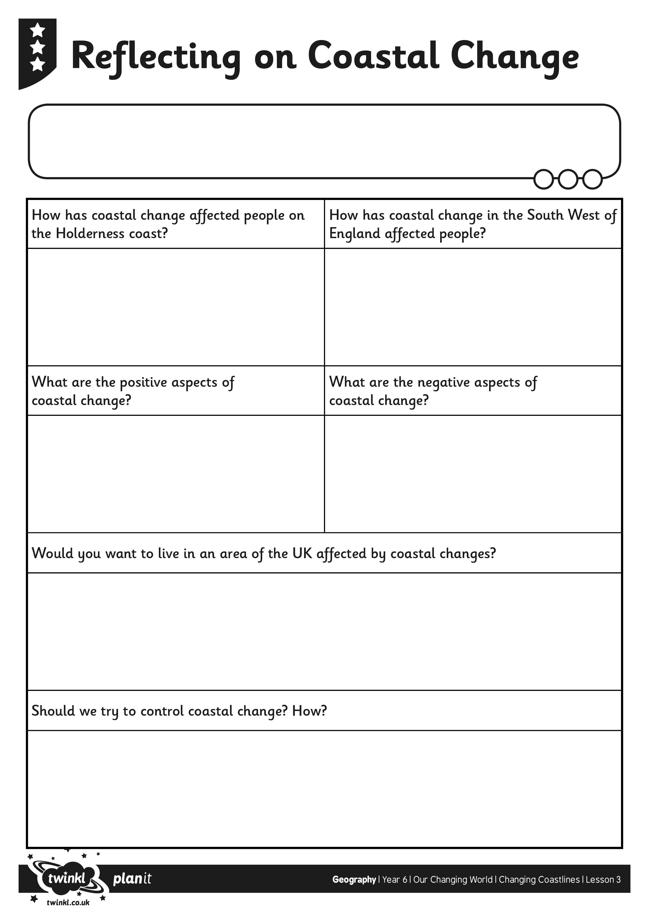
I can explain how water and weather can change coastlines.

